Deran:

Page 1
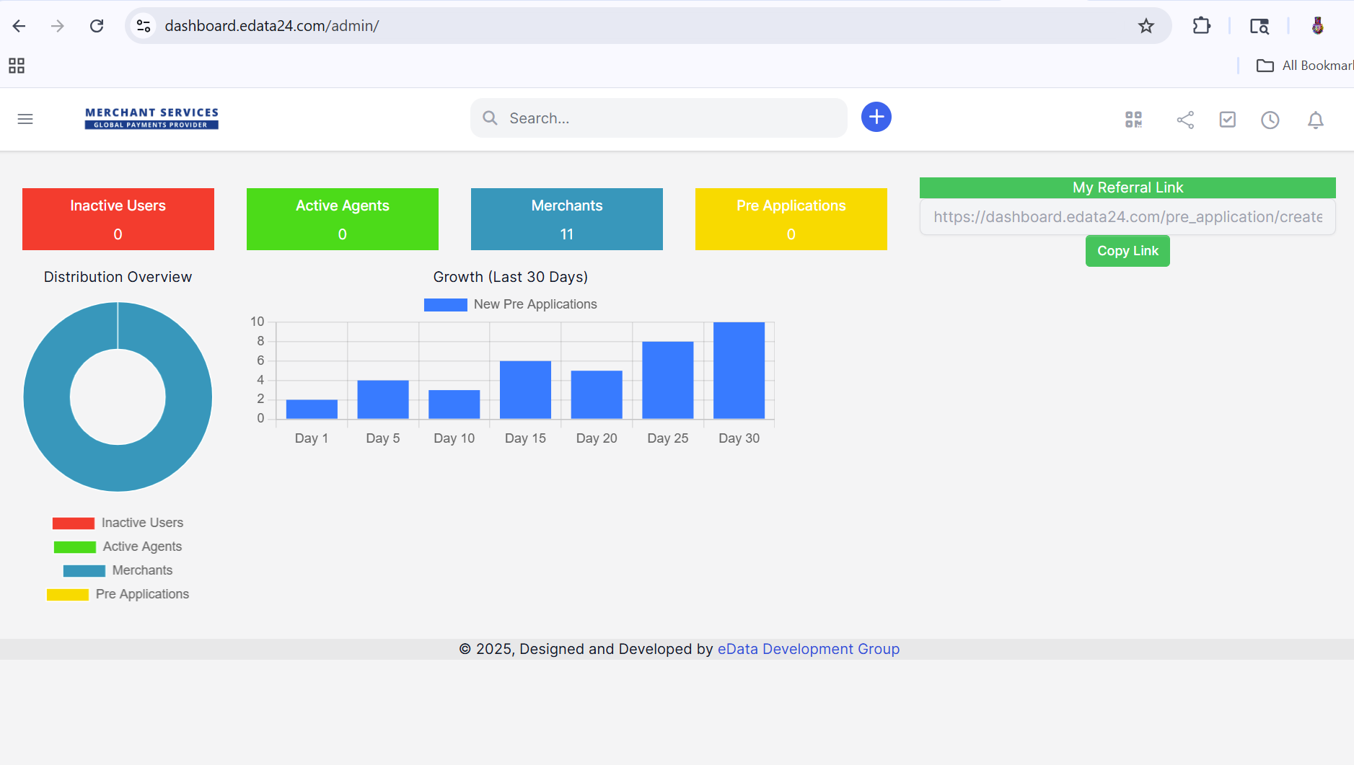
https://dashboard.edata24.com/pre_application/create?rid=0000008

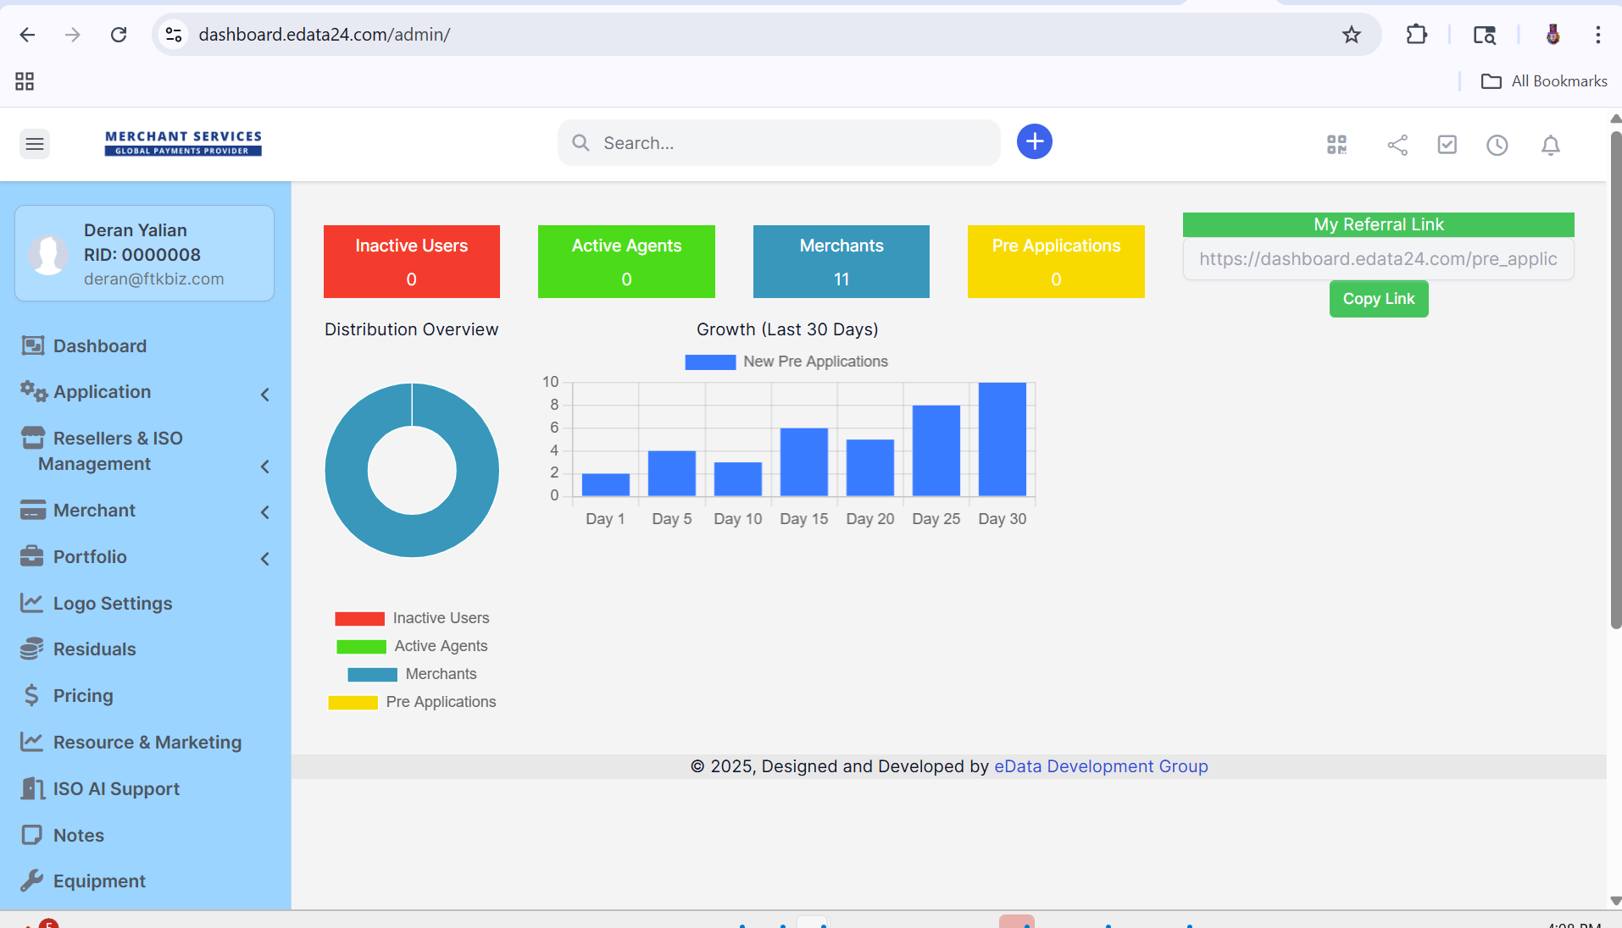

Agent:

Any Massages for the agents?
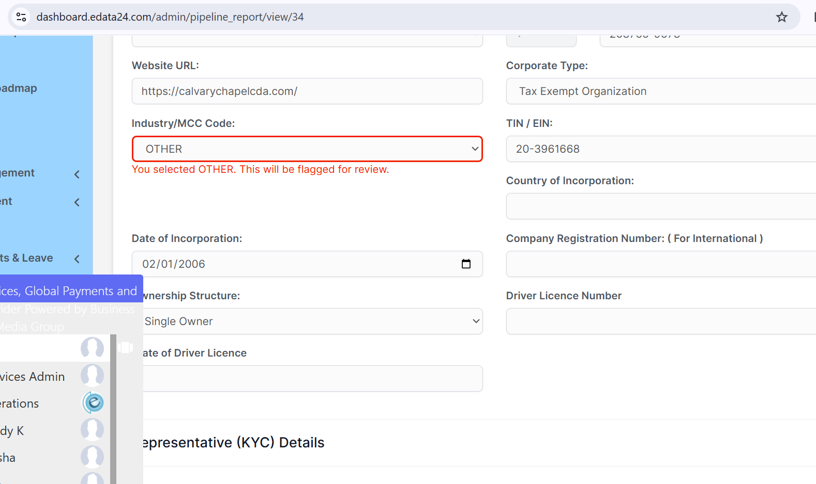

The Mcc is bed design
Still have issues with the phone numbers…
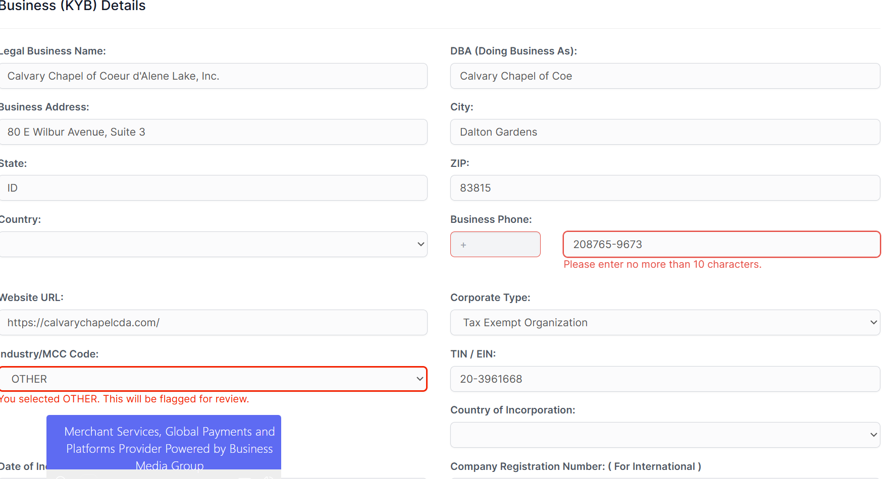

Where is the massage: ????
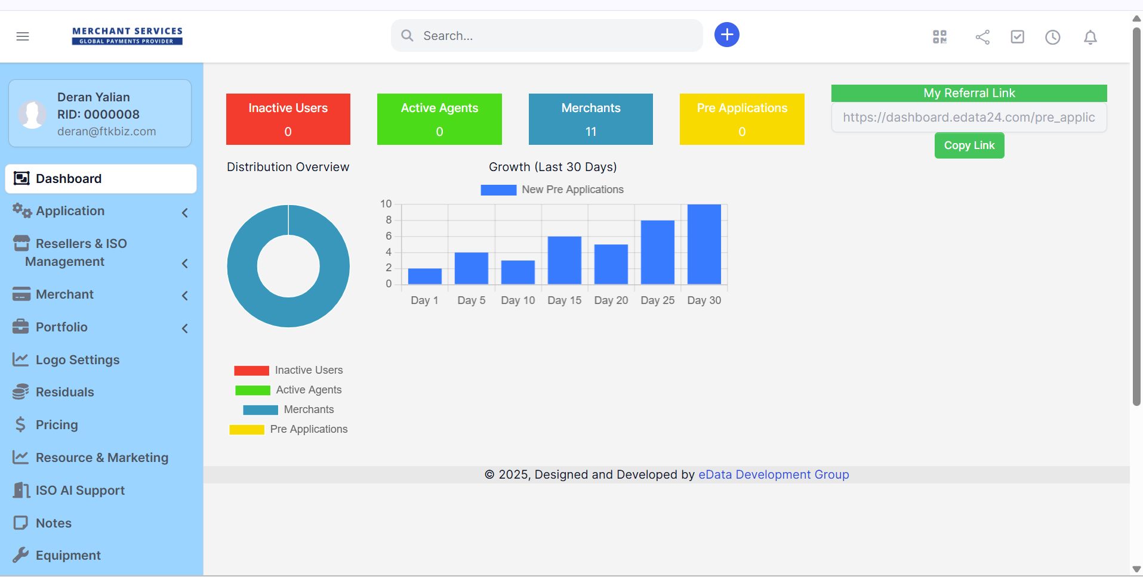

It is under the log

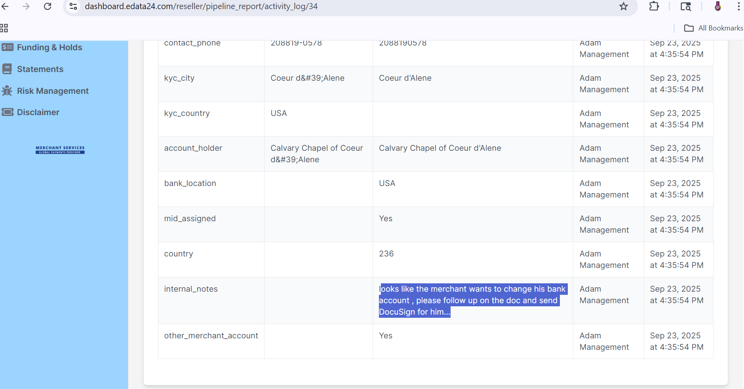
How do you reply to the management comments?
